**Group function/multi row function**

Group Functions operate on **group of rows to give one row result** per group.

We have **5 GROUP** functions,

1. Sum
2. Max
3. Min
4. Avg
5. Count

**Sum :**

It returns **total value**

**Max:**

It returns **maximum value**

**Min:**

It returns **minimum value**

**Avg**:

It returns **average value**

**Count:**

It returns **number of records**

**Ex – 1) display the maximum salary, minimum salary and total salary from employee**

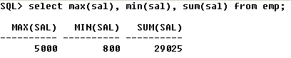

**2) The below query gives the total number of employees**

